**Create new app using existing solution – Sales and Marketing**

Model-driven app design is a component-focused approach to app development for Dynamics 365. In this topic, you simplify how to create an App for Sales and Marketing using the existing Sales Hub Solution.

We have three steps to proceed this exercise

* Step 1: Adding Sales and Marketing application in our environment.
* Step 2: Create new app using existing solution
* Step 3: Embed Canvas App in Dynamics 365 Model driven App

**Step 1: Adding Sales and Marketing application in our environment.**

1. Go To <https://trials.dynamics.com/> (we are using trial module for our session)

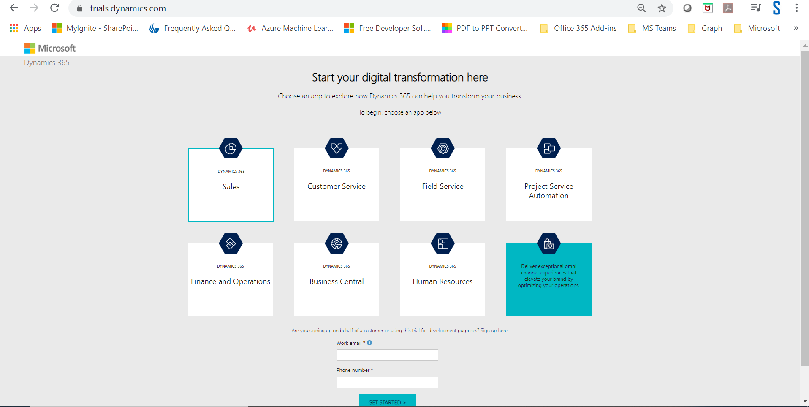

1. Select Sales

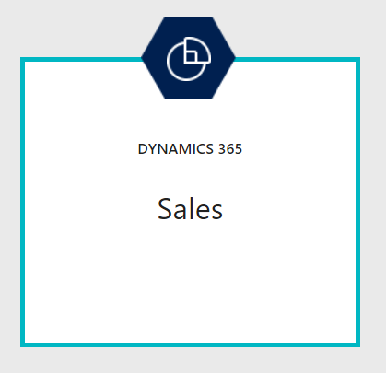

1. Enter Work Email, i.e. same email we created for office 365 developer subscription
2. Enter 10-digit Phone number

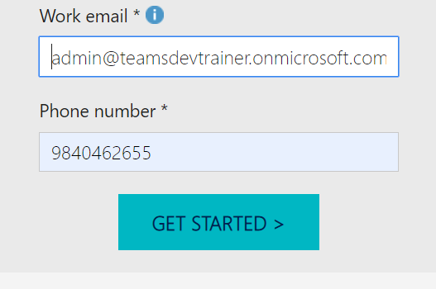

1. Click Get Started button, it will redirect to new window

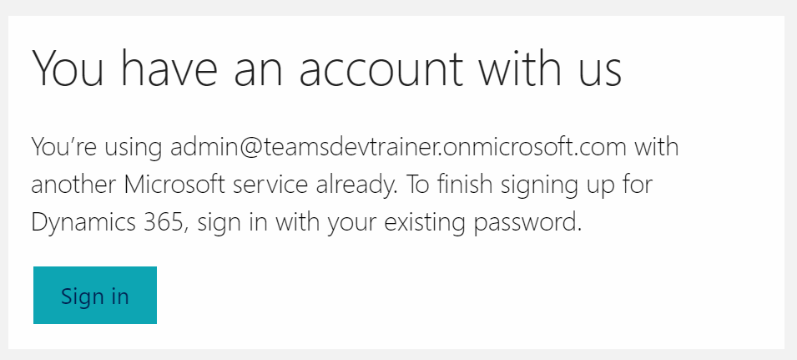

1. Sign In and continue
2. It will open the dynamics 365 environment area

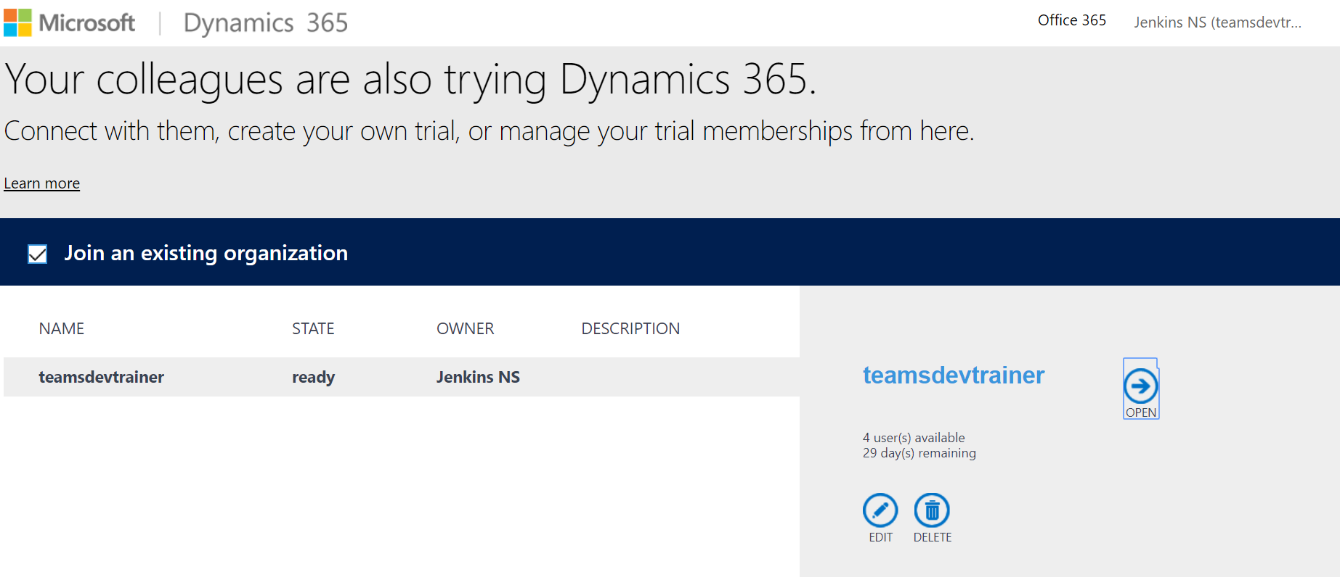

1. Click Open and see all our sales components

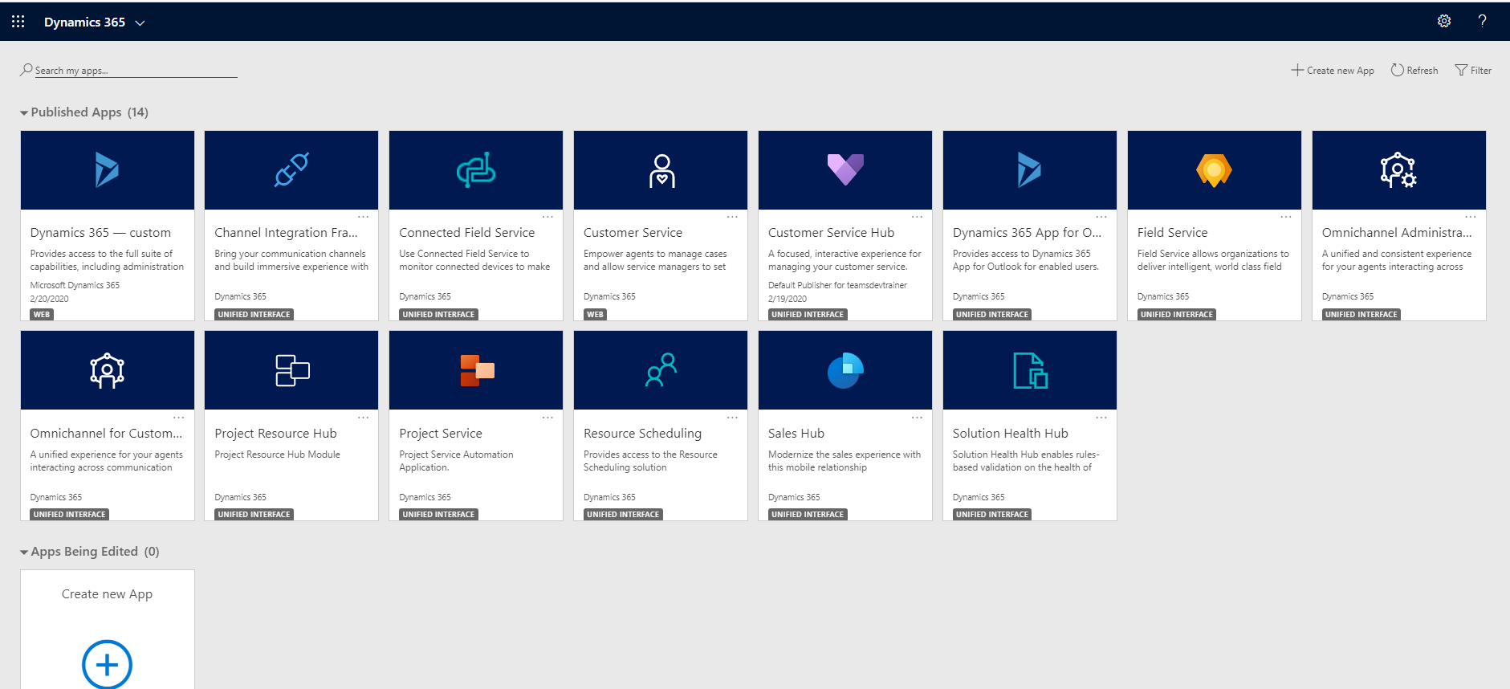

1. Now we are fine with create a custom Sales and Marketing app using Power Apps

**Step 2: Create new app using existing solution**

1. Click create new app link in the right-hand side

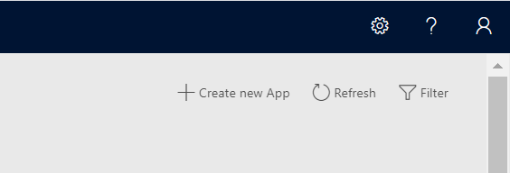

1. It will redirect to Powerapps Model driven app creation page

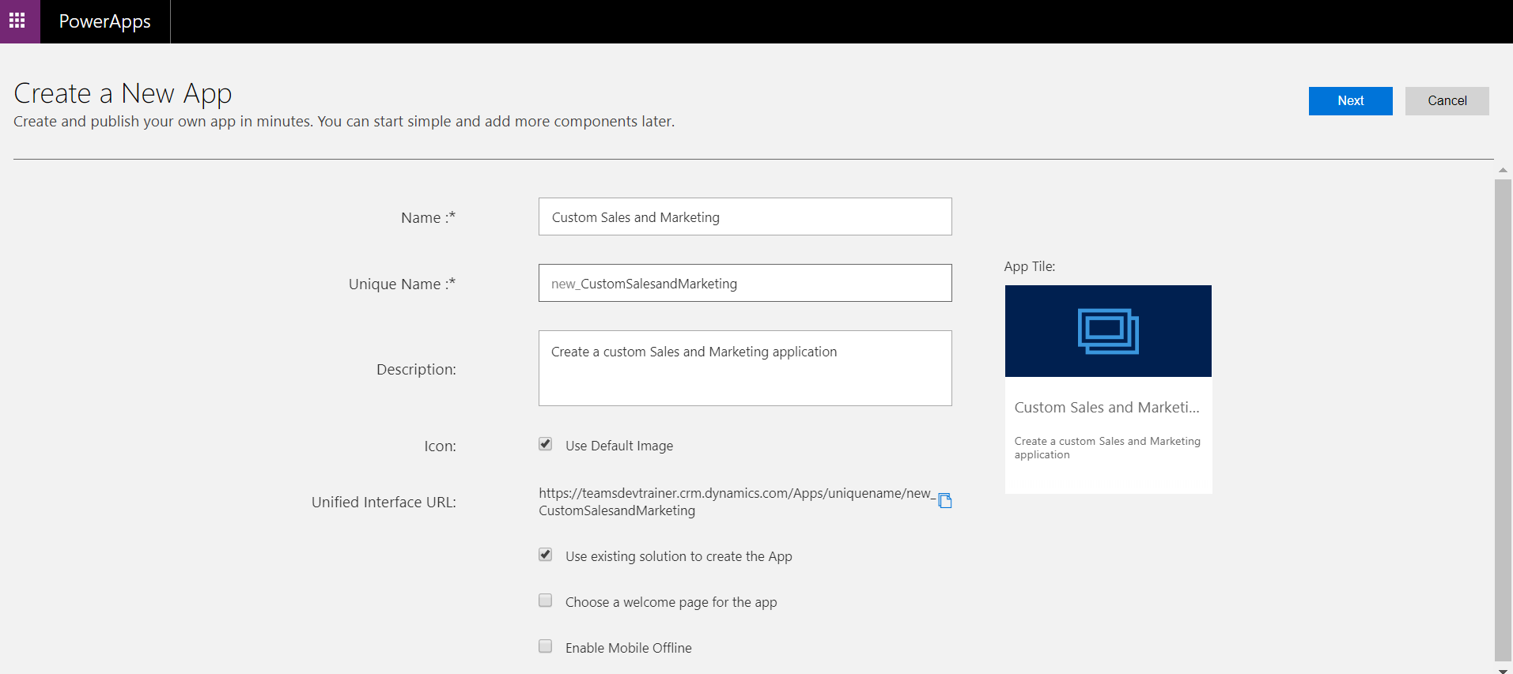

1. Give Name and description for the new app
2. Check “Use existing solution to create the App” to get the sales and marketing data source from the existing application.
3. Click Next button
4. Select Default Solution
5. Select ‘Sales Hub’ as Site map

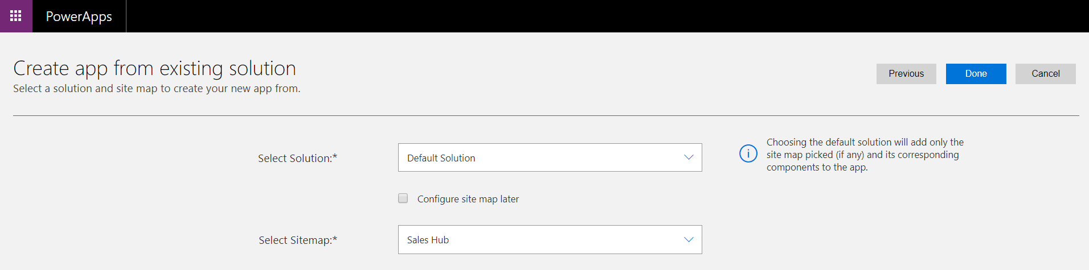

1. Click Done to create a custom app for Sales and Marketing
2. It will open the Power apps App designer and shows site map, Dashboards, Business Process and entities.

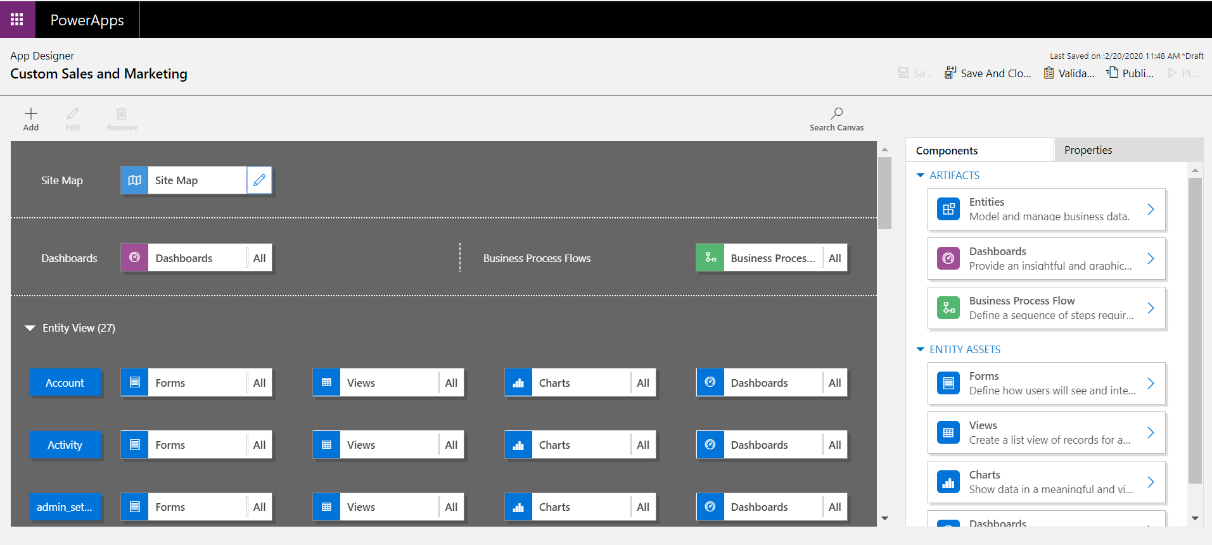

1. Edit the site map
2. Add/Modify the components

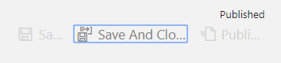

1. Save it
2. Publish it
3. Then go to entities
4. Create/remove/modify the forms, views, charts and dashboards
5. Then publish it
6. Play and test it, output looks below

